Filter Design Tool

# Objective

The object of this lab is to design different IIR filters using FDA tool.

# Theory

Filter Design and Analysis Tool (FDA Tool) is a Graphic User Interface for designing and analyzing filters. It is used to design FIR and IIR filters by entering the desired filter specifications, or by importing filters from MATLAB workspace or adding, moving, or deleting poles and zeros. After designing a filter, the response can be viewed and analysed in another Graphic User Interface tool named Filter Visualization Tool (FV Tool) linked with the FDA Tool, now called the filter design tool. The different types of responses that can be viewed are listed below:

• Magnitude response

• Phase response

• Group delay

• Phase delay

• Impulse response

• Step response

• Pole-zero plot

• Zero-phase plot

# Working with the Filter Design tool

In this section, you will learn how to use the Filter design tool. To begin, start MATLAB. Now, enter $filterDesigner$ into the command window. This should, when executed, bring up the FD graphical user interface (GUI), shown in Figure below.

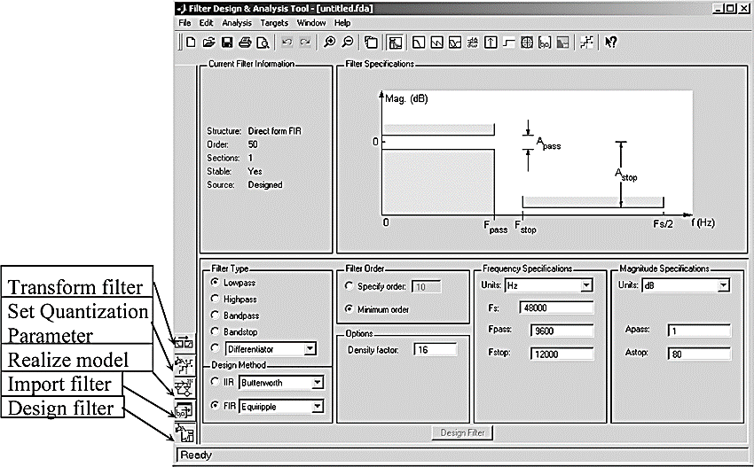

The GUI has three main regions:

* The Current Filter Information region
* The Filter Display region and
* The Design panel

The upper half of the GUI displays information on filter specifications and responses for the current filter. The Current Filter Information region, in the upper left, displays filter properties, namely the filter structure, order, number of sections used and whether the filter is stable or not. It also provides access to the Filter manager for working with multiple filters.

The Filter Display region, in the upper right, displays various filter responses, such as, magnitude response, group delay and filter coefficients.

The lower half of the GUI is the interactive portion of Filter Designer. The Design Panel, in the lower half is where you define your filter specifications. It controls what is displayed in the other two upper regions. Other panels can be displayed in the lower half by using the sidebar buttons.

The tool includes Context-sensitive help. You can right-click or click the **What's This?** button to get information on the different parts of the tool.

# Designing a Filter

The different steps involved in designing a filter using Tool can be listed as:

1. Selection of type of response required

2. Selection of type of filter design

3. Specifying the filter order

4. Entering the filter specifications

5. Entering the magnitude specifications

|  |
| --- |
| Designing a Low Pass filter Using Filter Design Tool We will design a low-pass filter that passes all frequencies less than or equal to 20% of the Nyquist frequency (half the sampling frequency) and attenuates frequencies greater than or equal to 50% of the Nyquist frequency. We will use an FIR Quirpele filter with these specifications:   * Passband attenuation 1 dB * Stopband attenuation 80 dB * A passband frequency 0.2 [Normalized (0 to 1)] * A stopband frequency 0.5 [Normalized (0 to 1)]   To implement this design, we will use the following specifications:    Select **Lowpass** from the dropdown menu under **Response Type** and **Equiripple** under **FIR Design Method**. In general, when you change the Response Type or Design Method, the filter parameters and Filter Display region update automatically.   1. Select **Specify order** in the **Filter Order** area and enter **30**. 2. The FIR Equiripple filter has a **Density Factor** option which controls the density of the frequency grid. Increasing the value creates a filter which more closely approximates an ideal equiripple filter, but more time is required as the computation increases. Leave this value at 20. 3. Select **Normalized (0 to 1)** in the Units pull down menu in the **Frequency Specifications** area. 4. Enter **0.2** for **wpass** and **0.5** for **wstop** in the **Frequency Specifications** area. 5. **Wpass** and **Wstop**, in the **Magnitude Specifications** area are positive weights, one per band, used during optimization in the FIR Equiripple filter. Leave these values at 1. 6. After setting the design specifications, click the **Design Filter** button at the bottom of the GUI to design the filter.   The magnitude response of the filter is displayed in the Filter Analysis area after the coefficients are computed.   Viewing other Analyses Once you have designed the filter, you can view the following filter analyses in the display window by clicking any of the buttons on the toolbar:    In order from left to right, the buttons are   * Magnitude response * Phase response * Magnitude and Phase responses * Group delay response * Phase delay response * Impulse response * Step response * Pole-zero plot * Filter Coefficients * Filter Information  Changing Axes Units You can change the x- or y-axis units by right-clicking the mouse on an axis label and selecting the desired units. The current units have a check mark.   Marking Data Points In the Display region, you can click on any point in the plot to add a data marker, which displays the values at that point. Right-clicking on the data marker displays a menu where you can move, delete or adjust the appearance of the data markers. |

|  |
| --- |
| Exporting Filter Design Once you are satisfied with your design, you can export your filter to the following destinations:   * MATLAB workspace * MAT-file * Text-file   Select **Export** from the **File** menu.    Once you are satisfied with your filter specifications, you can export them by navigating to File > Export and selecting "Export to Workspace" with the option set to "Coefficients". Provide a name for your coefficients file. This name will be used in your filter application. For example, I've saved the filter with the name "my_filter".  Based on the specifications mentioned earlier, I've created a low-pass filter that allows only signals equal to or lower than 4 Hz. Now, whenever you want to apply this filter to any signal, you can do so using the following command:    Replace "your_signal" with the signal you want to filter. This command will apply the filter coefficients stored in "my_filter" to your signal and store the filtered signal in the variable "filtered_signal". |

|  |
| --- |
| MATLAB Task 1  Write a MATLAB script to generate a composite signal composed of three individual signals: a 100 Hz sinusoidal waveform, a 500 Hz sawtooth signal, and a 800 Hz pulse signal. Follow the steps outlined below:  1. Define the sampling frequency `fs` as 10,000 Hz and create a time vector `t` spanning from 0 to 1 second  2. Generate the individual signals:  - A sinusoidal signal with a frequency of 100 Hz.  - A sawtooth signal with a frequency of 500 Hz.  - A square pulse signal with a frequency of 800 Hz.  3. Display each individual signal separately using subplotting. Ensure proper labeling of the axes and titles for each subplot.  4. Aggregate the individual signals into a composite signal by summing them together.  5. Plot the composite signal in a new figure, with proper labeling for the axes and a descriptive title.  6. Calculate the Fast Fourier Transform (FFT) of the composite signal and center it frequency  7. Plot the magnitude of the FFT against frequency in a new figure. Properly label the axes and title the plot accordingly.  8. Utilize the FDA Tool to design three different FIR filters:  -  9. Configure each filter with appropriate parameters and characteristics to isolate the desired frequency range. Ensure that the filter designs are well-documented, including descriptions of their properties, shapes, frequency responses, phase responses, and zero-pole diagrams.  10. Apply each filter to the composite signal to extract the orignal. Plot the filtered signals alongside the original composite signal in both the time and frequency domains. Ensure that the axes are properly labeled and titles are descriptive.  11. Comment on the effectiveness of each filter in accurately extracting its respective signal component. Discuss any observed discrepancies or artifacts in the extracted signals compared to the original individual signals.  12. Attach screenshots of the FDA Tool showing the filter designs and characteristics, as well as screenshots of the MATLAB figures displaying the filtered signals. |

|  |
| --- |
| MATLAB Task 2:  Imagine you're working with three distinct audio sources, such as musical notes, environmental sounds, motor sounds, or speech recordings. The first two sources represent different instruments, voices, or sound effects, while the third source contains your own voice. Your task is to combine the first two sources with the third source and analyze the resulting signals.  1. Load three audio files representing the aforementioned sources and store them as signals.  2. Adjust the signals to have equal length, ensuring consistency for further processing.  3. Combine the first two signals with the third signal to create two new composite signals.  4. Save the composite signals as new audio files with names of your choosing.  5. Analyze the frequency content of the composite signals by computing their Fast Fourier Transforms (FFTs) and plotting the magnitude spectra.  6. Playback the composite signals to listen to the merged audio, with a pause between playback sessions.  7. Optionally, apply signal processing techniques such as filtering to the composite signals to extract your voice  8. Re-analyze the frequency content of the processed signal and compare it with the original.  Ensure your MATLAB script is well-commented and organized, and execute it to observe the effects of combining and processing the audio signals. |